Directions: This is a closed-book, closed-note test with one and 1/2 hours allotted. Some questions are more difficult than others so allocate your time wisely. If any question is ambiguous, state your assumptions and answer the question based on your assumptions. You do not have to turn in this document.

- (20 points) Process Definition: A process is a “program in execution.”
- Describe the salient features or characteristics associated with a process that differentiates it from a program.

When a process is created, the program is copied into (virtual) memory and is provided with 4 sections: heap, stack, code, and data. The code and data sections come directly from the program image on disk but the heap and stack segments are created for program execution.

In addition to the memory image, the OS builds a PCB (Process Control Block) that is used to manage the process and to save all relevant process state information. Process state includes: register information, open files, statistical information, memory limits, etc.

As we saw with the “exec” family of system calls, each process has a number of open files that are part of the process and not the program. All process will have three files open upon the start of program execution: stdin, stdout, and stderr. In addition, the process will have environment information, and command line arguments associated with it in which the program will not.

- Enumerate and explain (briefly) all the operations that can be performed on processes.

A process can be created and terminated. The creation process is performed by a system call, e.g., “fork().” The child process is entered into the process status diagram via the admit edge. The parent process can either continue executing independent of its child or be required to wait until the child terminates. When the child is created it can either be a duplicate of the parent process or the child process has a new program loaded into it.

When a process is terminated, its PCB is removed from the system and its return value is sent to its parent process.

In addition to these two fundamental operations, there are also mechanisms in which the processes can communicate with other processes.

- (20 points) Modeling Processes
- Draw the Process State Diagram, labeling all edges and states.
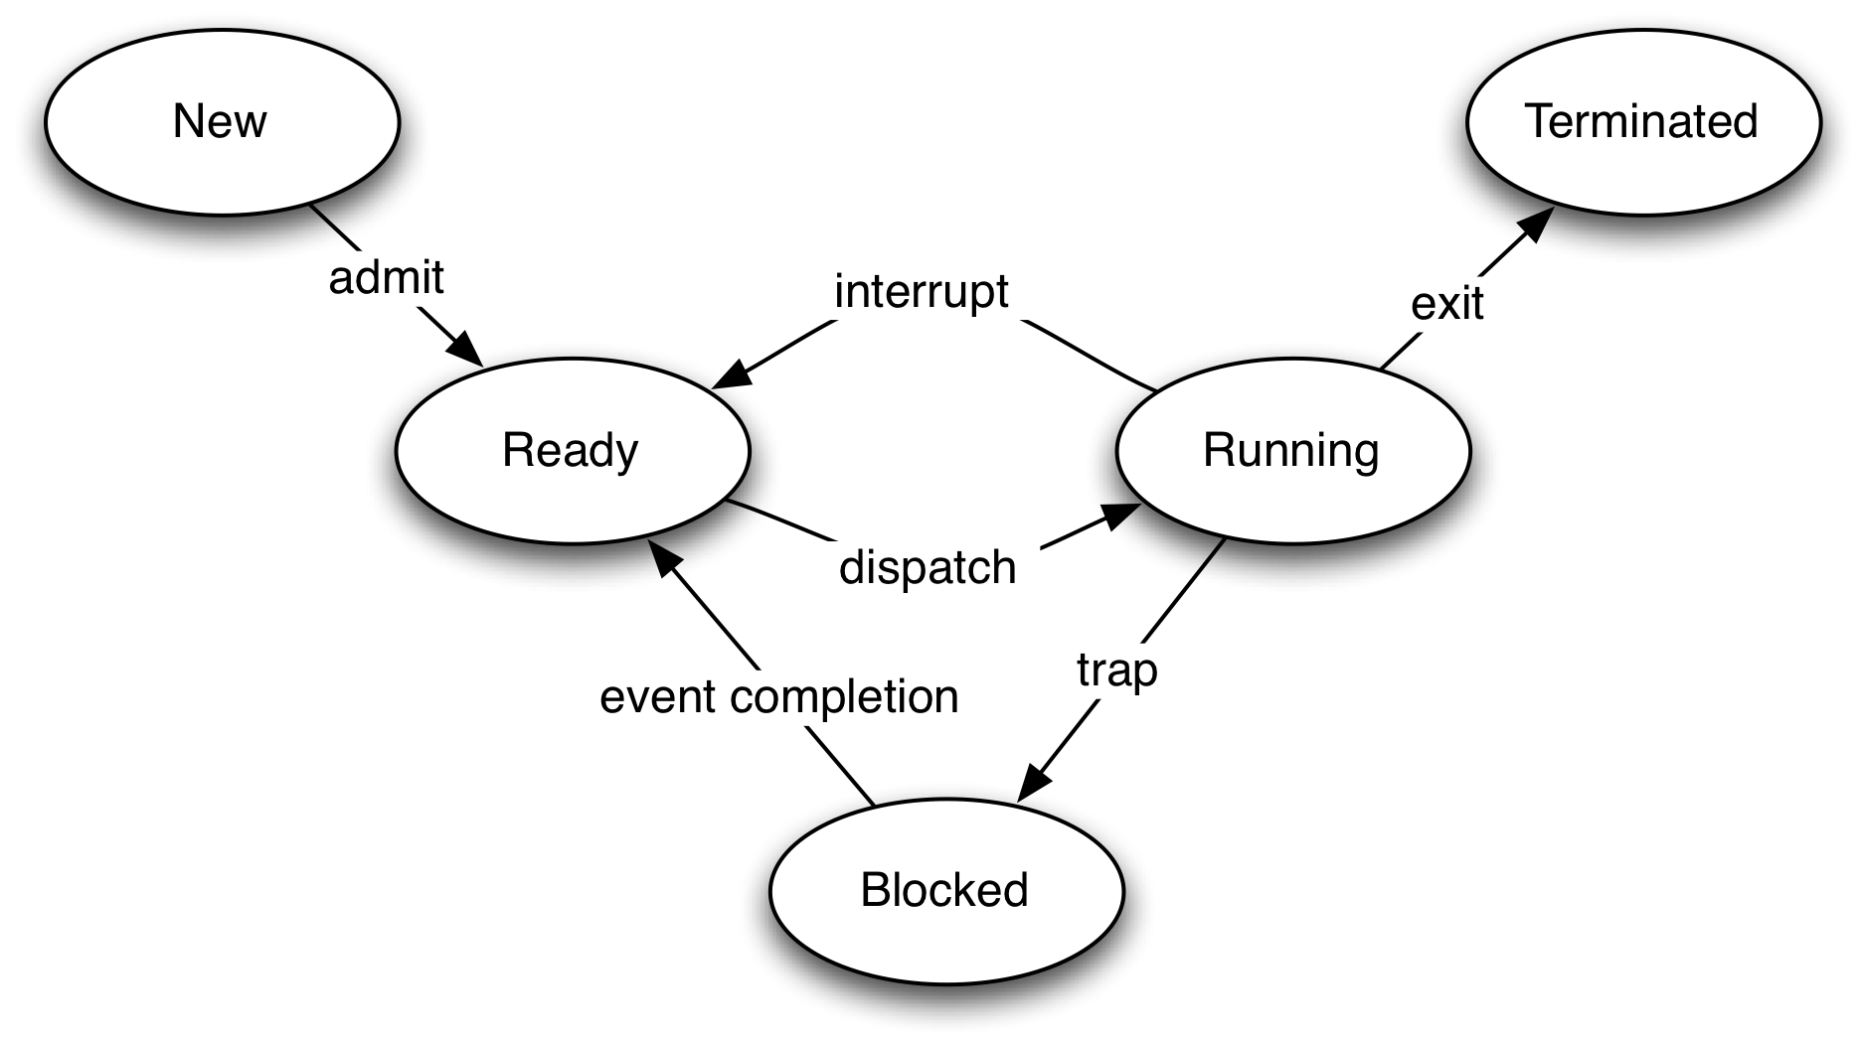
- Enumerate which of the edges are related to scheduling events and why. (Recall that this question may have several answers, hence the “why” is the important part of the question.)

I claim that there are only two edges when a scheduling event occurs. These two events when the running process is removed from the running state upon an interrupt or a trap. At these points, the process has created a new child process via, e.g., “fork()” – which needs to be scheduled or the OS has decided that a new process needs to be allocated the CPU (i.e., an interrupt has occurred). The OS will update the Ready Queue and then dispatch the head of the queue.

I did not include the exit edge, because this is really a trap to the OS. I also did not include the event completion, because for this edge to be traversed the running process must have first flowed to another state via the interrupt or trap edge, and hence the use of these edges induce the scheduling event.

- When the Operating Environment performs a context switch, what information needs to be saved for later use, where is this information stored?

The values of all registers must be saved. This information is stored within the PCB.

- (25 points) Job Scheduling: Three jobs, A, B, and C, arrive in the system at the same time – at time zero. Each process has different CPU- and IO-burst; these times are 3-3, 5-1, and 1-5, respectively. In the following execution profile, which uses a scheduling methodology that gives priority to the job that has spent the longest time in the ready queue, answer the following questions:
  - What is the average turnaround time for the system?

(29 + 28 + 27)/3 == 28

  - Is this system a preemptive system? If it is preemptive, which is its time quantum?

Yes, this is a preemptive system since jobs that are in the “running” start are removed upon an IO-completion.

There is not sufficient information in the table below to determine the exact value of the time quantum. However, the time quantum is 3 or more units in length.

  - Enumerate the type of event/s that occurs at the following times:
0, 6, 15, 28

Time 0: “admit”, three jobs are admitted into the system.
“dispatch”, Job A is moved into the Running state
Time 6: “interrupt”, Job A’s IO-Burst completes, and B is moved to Ready
“IO-complete”, Job A is moved to the Ready state
“dispatch”, Job C is moved into the Running state
Time 15: “trap”, Job C starts its IO-burst
“dispatch”, Job B is moved into the Running state
Time 28: “exit”, Job C completes
“dispatch”, Job B is moved into the Running state

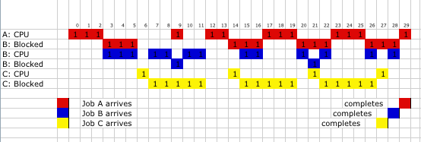

- (20 points) Thread Models: One of the benefits provided by threads is responsiveness. As stated by our textbook, “Multithreading … may allow a program to continue running even if part of it is blocked or is performing a lengthy operation, thereby increasing responsiveness to the user.” Our textbook also describes three multithreading models.
- Enumerate and describe these three models.

Threads come in two flavors: user-level and system- (kernel-) level threads. The relationship between these two flavors defines the three models, which also dictate they overall behavior or operation. The three models are: many-to-one, one-to-one, and many-to-many.

Many-to-One: A process may have many threads, but all of these user-level threads are mapped onto a single kernel-level thread. Hence all scheduling is performed on a per process basis. The user can create as many threads as they want, but no true concurrence is gained.

One-to-one: A process may have any number of threads. Each of these threads are mapped onto a their own kernel level thread. Hence all scheduling is performed on a per thread basis. The user can create any number of threads – each yielding concurrency, but the user must be careful not to create (provision) to many threads.

Many-to-many: Depending on an application or system, all user-level threads are grouped, and each group is then mapped onto a single kernel-level thread. Under this model, concurrency can only be obtained between the groups and over provisioning can be controlled.

- Which of the three models does not allow a program continue running if one of its threads blocks? Explain your answer.

The easiest answer is the many-to-one model. Once a single user-level thread blocks, the corresponding kernel-level thread also blocks. Since all the user-level threads are mapped to the same kernel-level thread --- ALL the threads block.

The Many-to-many model may also not allow a program to continue execution IF all the user-level threads are mapped onto the same kernel-level thread. But this would be a degenerate cause that would make this model the same as Many-to-one.
- (15 points) Interprocess Communication: From a general perspective, explain what a pipe is and some of its possible characteristics (naming, synchronization, and buffering.)
A pipe is a type of file that allows communication between two ends. The communication can either be bidirectional or unidirectional. (The “pipe()” call within the standard C library is a unidirectional communication device.)

Pipes – as with other communication devices – can be named or unnamed. E.g., you can create a named pipe via the CLI command “mkfifo”. Once the pipe has been established, you interoperate with it just as you do with any other file.

Each pipe will have an internal buffer that can have in capacity: zero, and bounded, unbounded. These buffer capacities have an impact on the type of synchronization that must be maintained by the two cooperating processes. (Note it is possible for one process to manage both sides of a pipe.)

The operations on the pipe, read and write, can either be synchronous or asynchronous. If they are synchronous operations, the associated library call “blocks”, otherwise it is non-blocking. It is typical that sends are asynchronous and receives are blocking.

- (5 points) Define what a zombie process is. What information is associated with such a process, and why do we have such a process?

It is a process that has completed, but its PCB cannot be removed from the system. It must wait in the “Terminated” state until its parent retrieves its return value.

This question is not specific to Unix Pipe that you used in the laboratory assignment, but rather to the general concept of a pipe.

